“Folia Drakou” Cave (Potamoi, Drama, Macedonia, Greece)
Geological and Speleological study - Preliminary report
Vaxevanopoulos Markos¹, Lazaridis Georgios², Zachariadis Stavros³, Pennos Christos² & Garlaouni Charikleia²
- Ephoria of Paleoanthropology & Speleology, N. Greece, Ministry of Culture
- School of Geology, Aristotle University, 54124 Thessaloniki, Macedonia, greece
- School of History & Archaeology, Aristotle University, 54124 Thessaloniki, Macedonia, greece

Abstract
The “Folia Drakou” cave is situated in the broader area of the Potamoi village, in the prefecture of Drama (Macedonia, Greece). The region belongs to the Sidironero geological unit of Rhodope massif. The cave has been formed into marbles, sipolines and gneisses. The speleogenesis of the cave and the anthropological findings are first presented. Characteristic shapes of karstic tubes, breakdown formations, human bones (cranium) and ceramics are singularly described.

Introduction
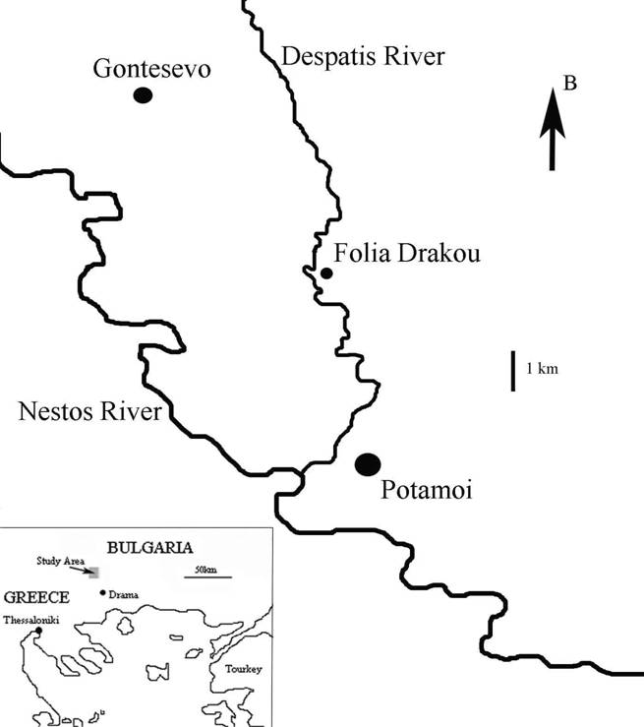
The “Folia Drakou” cave is located in the Despatis basin, close to the Potamoi village of Drama prefecture, 100km NE from the city of Drama. In the broader area of Potamoi village a number of karstic caves were developed. The most interesting karstic formation is the “Folia Drakou” cave in which archaeological and anthropological findings have been observed. The cave presents passages with characteristic shapes, which are formed along the tectonic and stratigraphic discontinuities as well as breakdown morphology. The first visit for reconnaissance to the cave took place by the archaeologists in 1982. Since 2004 the cave has been explored and mapped twice by members of the Department of Northern Greece of the Hellenic Speleological Society.

Geological Setting
The broader area of the “Folia Dragou” cave belongs to the Rhodope Massif, which is distinguished into the Sidironero and Pangeon Unit, both consisting of metamorphic rocks. The Sidironero complex consists of a Paleozoic sequence mainly filled with gneisses and intercalations of orthogneisses, two-mica paragneisses, augen-gneisses, amphibolites, mylonites and thin embedding layers of marbles, migmatites. Plutonic bodies have intruded in the area. The cave is formed within marbles and gneisses close to the thrust zone, where the upper Sidironero unit thrusts over Pangeon unit, with a 101° strike and a SW dip following the riverbed of Nestos (Fig. 2, Falalakis, 2004).
Figure 1. Map of northern Greece with the Drama area, the Potamoi village and the location of the Folia Drakou Cave.

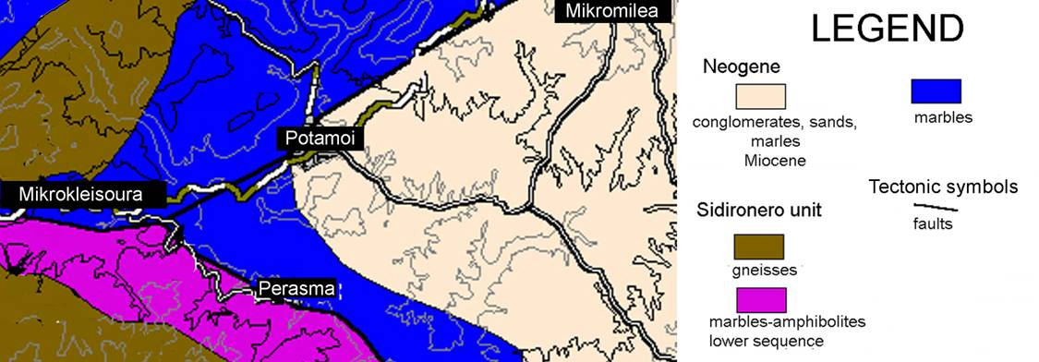
There are three phases of folding, including isoclinal folds NE-SW, asymmetric conjugated folds trending from NE-NW to ENE-WNW and open folds trending NW-SE. The second folding event is associated with the development reverse faults striking NE-SW, which predominate in W. Rhodope (Kilias & Mountrakis, 1990). The stress field is nowadays characterized by the maximum tensional axis having a direction from NNW-SSE to NNE-SSW, with the last one being dominant. The seismicity of the area is rather sparse. The tension is characterized as oblique, normal with a dextral component of slip (Mountrakis & Papazachos, 2003).
Figure 2. Geological map of the broader area of the potamoi village (based on Falalakis, 2004).

Archaeological setting
The region of Potamoi has always been a crossroad for different civilizations. Human activity in this area is evident for a very long period. Archaeological research has brought to light findings that date since the prehistoric age up to the late roman era (Peristeri, 2002).

Excavations were contacted in the area (Koukouli, 1967, 1976, Peristeri, 2002) by the 18th Ephoria of classical and prehistoric antiquities. The excavations concerned mostly tombs that were dated by numismatic evidence and ceramics in the 1st century A.C. and a tomb of the late copper age positioned at the junction of the forest streets Mikromilias – Kourou. In addition a settlement of the late copper age was spotted and excavated in the same area at the site known as Eski Borovo.

Inside the cave ceramics of different ages were scattered, possibly due to an illegal excavation. No evidence of inhabitance of the cave by human during the antiquity is present and only a systematic excavation can give evidence how the ceramics were brought into the cave. For the time being there is no clear connection between the human bones found in the cave and its possible use by humans at any time.

Morphology of the cave
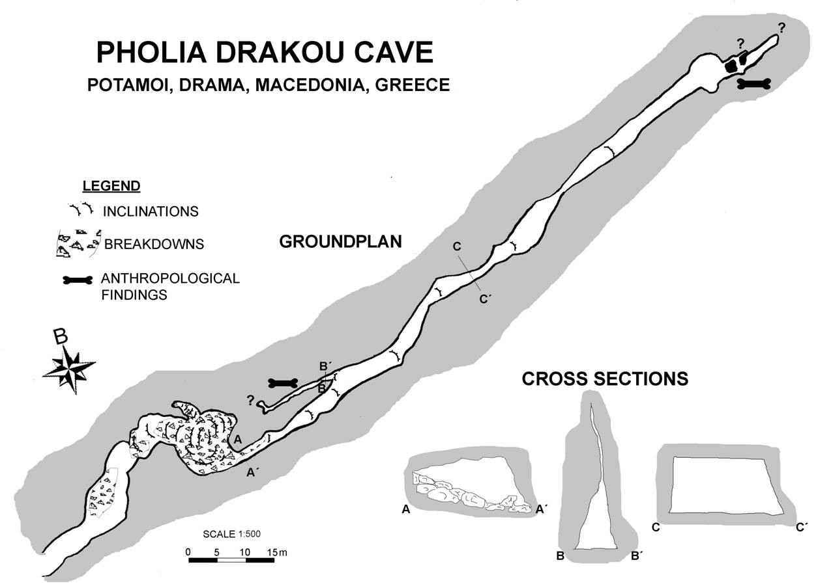
The “Folia Drakou” cave is a karstic tube about 200m long, developed in intercalations of marbles and gneisses. The entrance of the cave is 4.0m above Despatis River water level. The height of the cave ranges from 0.5 to 5.0m about, and the breadth varies from 0.5 to 12.0m (Fig. 3). The maximum dimensions of the cave are close to the entrance, where
Figure 3. Ground plan and cross sections of the Folia Drakou Cave (Potamoi, Drama, Macedonia, Greece).

breakdown morphology is observed (Fig. 4). These increasing dimensions are due to successive collapses that resulted in the greatest chamber of the cave to be formed. The almost horizontal foliation contributes to the process of the collapses and the formation of the breakdown morphology. Breakdown facts occur both early and very late to the speleogenetic process (White & White, 2000), the latter one being noted in this cave as well. The floor of the cave is fully covered with fine-grained sediments, flowstones and collapsed blocks. These deposits are mainly autochthonous, originating from the cave interior, while some of them being possibly fluvial.

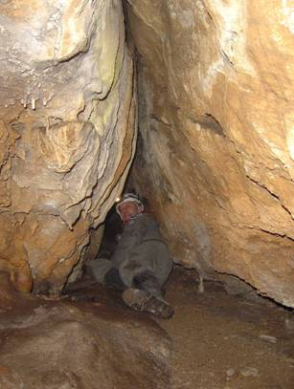
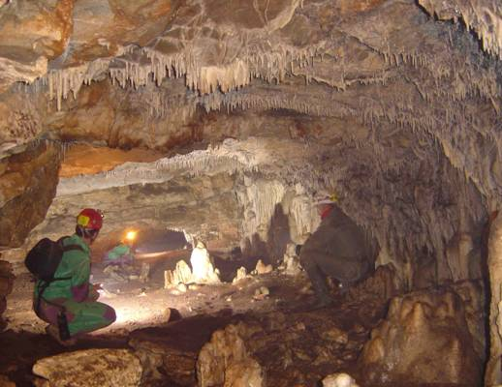
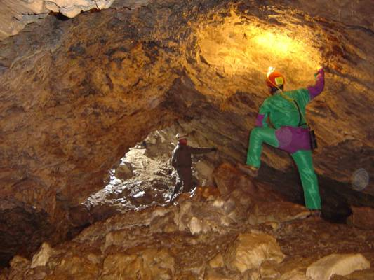
The speleogenesis took place in a phreatic stage. Phreatic karstic tubes have usually a circular shape when they are developed along the crossing of a joint and the foliation of the rock (Lauritzen & Lundberg, 2000). Despite the fact that a similar crossing leads the development of the “Folia Drakou” Cave, the passages have different shapes. The cross sections of the tube have either triangular or trapezoid shape. The triangular shape is noticed when the water corrosion follows almost vertical joints with the contribution of the foliation being inessential (Fig. 5). The existence of the 2 joints to the sidewalls and the foliation of the ceiling give trapezoid shape to the passages of the cave in cross sections (Fig. 6). These passages had an original circular shape in the beginning that changed to trapezoid due to the collapses. If the collapsed blocks remain in place the shape seems rather triangular.
Figure 5. The “Folia Drakou” cave: a passage of a triangular shape.
Figure 6. The “Folia Drakou” cave: a passage of a trapezoid shape.

Figure 4. The “Folia Drakou” cave: the greatest chamber close to the entrance, where the breakdown morphology has been observed.

Concerning speleothemes the “Folia Drakou” Cave presents a great variety. There are stalactites, stalagmites, flowstones, shields, columns, gours, mainly of young age. They are mainly marked to the deepest part of the cave.

Finally, concerning the anthropological findings, the most important calcite-covered skull has been found in the deepest part of the cave, with a rounded hole on the frontal-parietal area. Further more, post cranial bones such as a femur, a tibia, vertebras, pelvis etc, have been observed in other places of the cave (Figs. 3, 7)

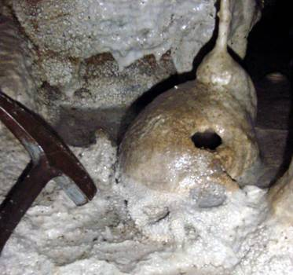
Conclusions
- The “Folia Drakou” Cave is the most interesting cave of the Potamoi region because of the special geological, speleological, archaeological and anthropological interest that presents.
- The cave can be described as a karstic tube is of phreatic origin.
- The broadening of the cave is associated with successive collapses.
- Triangular shaped passages are observed along almost vertical joints whereas trapezoid ones are developed according to the tectonic features of the rock.
- The presence of ceramic findings adds archaeological interest to the cave.
- A number of human skeleton remains including a skull give an anthropological interest.
Figure 7. The “Folia Drakou” cave: The human calcite-covered skull, with a rounded hole on the frontal-parietal area, found in the deepest part of the cave.

Acknowledgments
We would like deeply to thank our colleagues K. Polydoropoulos, V. Makridis, E. Partsios for their substantial contribution and help during the field work.

References
Falalakis G., 2004. Kinematic analyses and deformation at the boundary of crystalline Serbomacedonian and Rhodope massifs (Mountains of Kerkini- Vrontou, Makedonia). Thesis Dissert. School of Geology, Aristotle University, p. 1-153, Thessaloniki. (in Greek)
Kilias, A. & Mountrakis, D., 1990. Kinematics of the crystalline sequences in the western Rhodope massif. Geologica Rhodopica, 2: 100-115.
Koukouli, C., 1967. “Archaeologikon Deltion”, chronicles, 22: 427 – 428 (in Greek)
Koukouli, C., 1976. “Archaeologikon Deltion”, chronicles, 31: 304 (in Greek)
Lauritzen, S.-E. & Lundberg, J., 2000. Solutional and Erosional Morphology. In: “Speleogenesis. Evolution of Karst Aquifers”. A. B. Klimchouk, D. C. Ford, A. N. Palmer & W. Deybrodt (eds.) - National Speleological Society: 408-426, Huntsville, Alabama.
Mountrakis, D. & Papazachos, K., 2003. Determination of the characteristics and the seismotectonics of the main active faults in North Greece with the use of neotectonic and seismic data. Unpublished final report submitted to the Earthquake Planning & Protection Organization (EPPO, in Greek).
Peristeri, K., 2002. excavations of burial tombs at Potamoi of Drama. Archaeological acts in Macedonia and Trace 16: 137 – 144. (in Greek)
WHITE, E. L. & WHITE, W. B., 2000. Breakdown Morphology. In: “Speleogenesis. Evolution of Karst Aquifers”. A. B. Klimchouk, D. C. Ford, A. N. Palmer & W. Deybrodt (eds.) - National Speleological Society: 427-429, Huntsville, Alabama.

